Professional Photography offered by

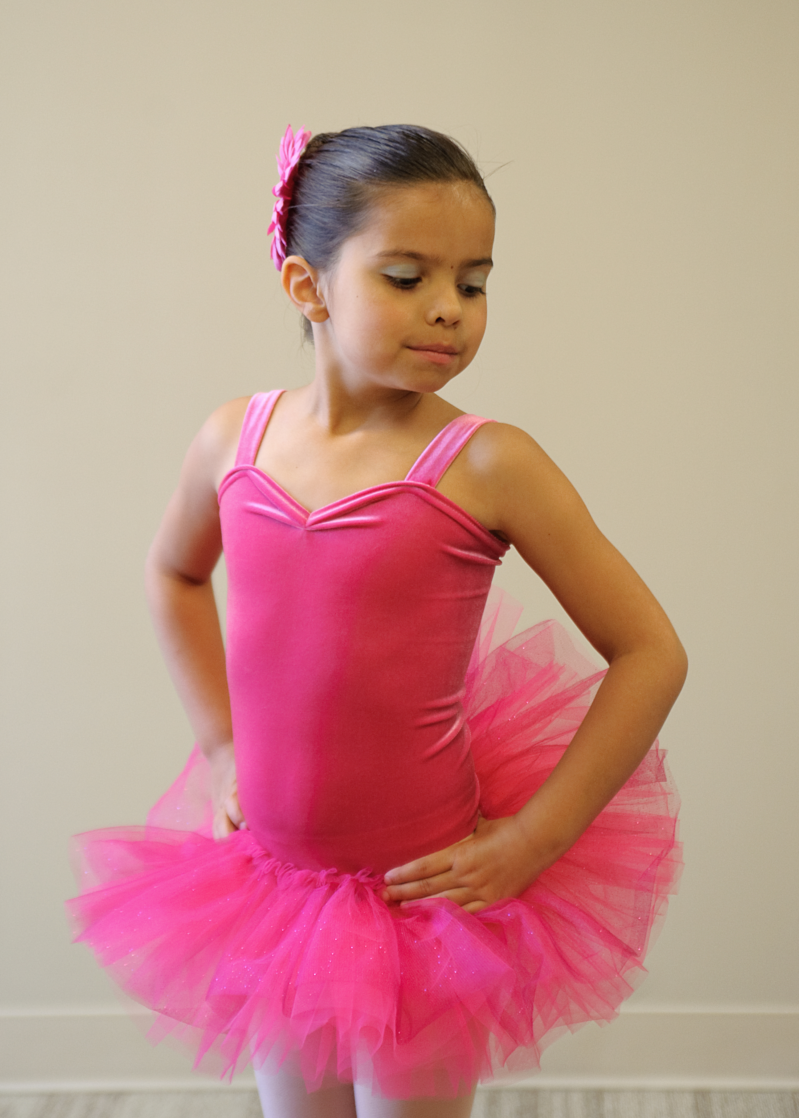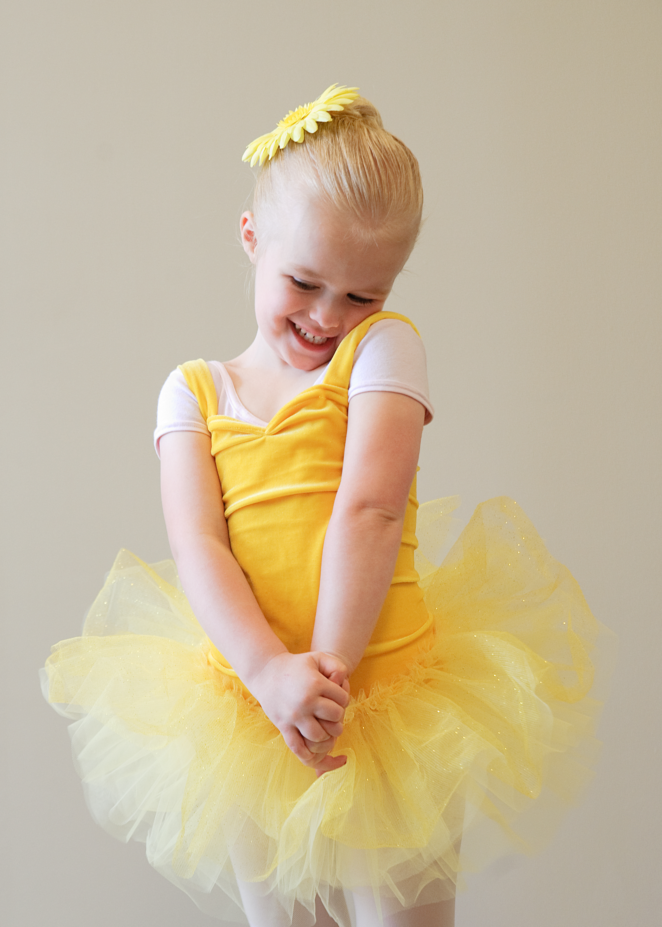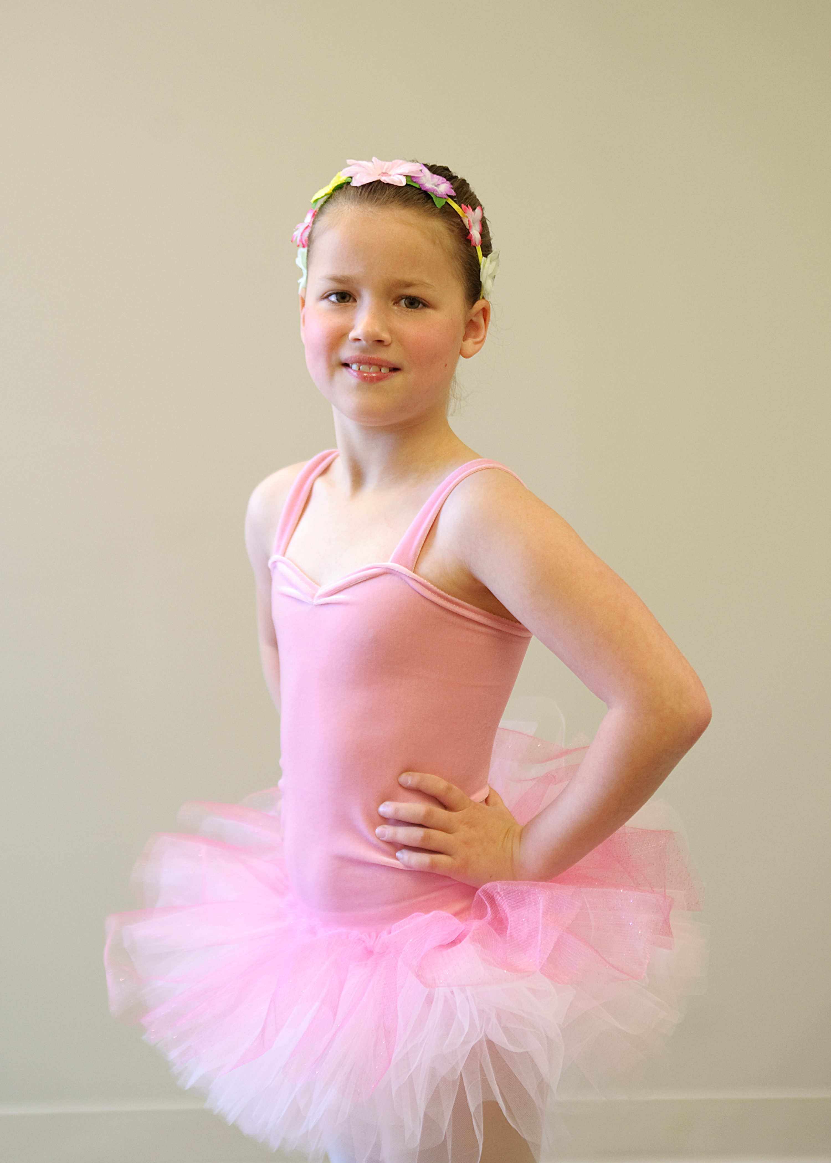

- Individual and group pictures will be taken of every dancer on the day of the rehearsal

- No obligation to buy

- Photo prints and digital files available at reasonable prices

- Within 2 weeks of recital day families will receive a link to a password-protected, online gallery along with ordering information

Please contact dionsenecaphotography@gmail.com or 571-488-3752 for questions.
www.dionsenecaphotography.com

